Step-1: Now, Commit the container and create new container image.

**Command: # docker container commit –author “Sandeep Anuragi” -m “my_ubuntu” container_id my_ubuntu**

**After that check the container image:**

**Command: # docker image ls**

**Status:**

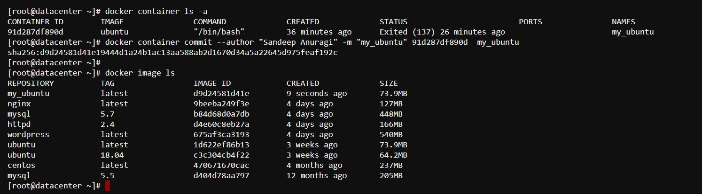

Step-2: Save the container image for backup purpose.

**Command: # docker image save my_ubuntu > my_ubuntu_image.tar**

**Status:**

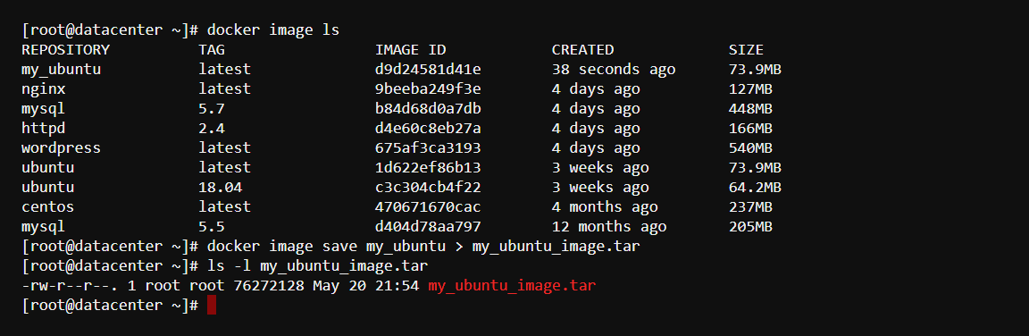

Step-3: Remove the container image

**Command: # docker image rm -f my_ubuntu**

**Status :**

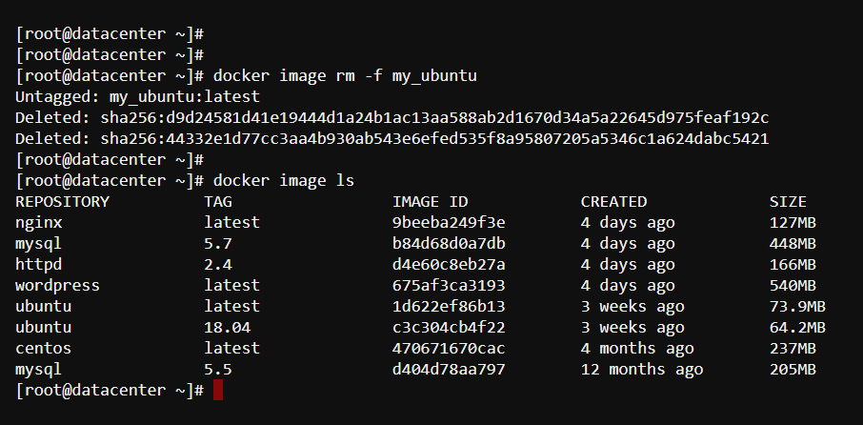

Step-4: Load the container.

**Command: # docker image load < my_ubuntu_image.tar**

**Status:**

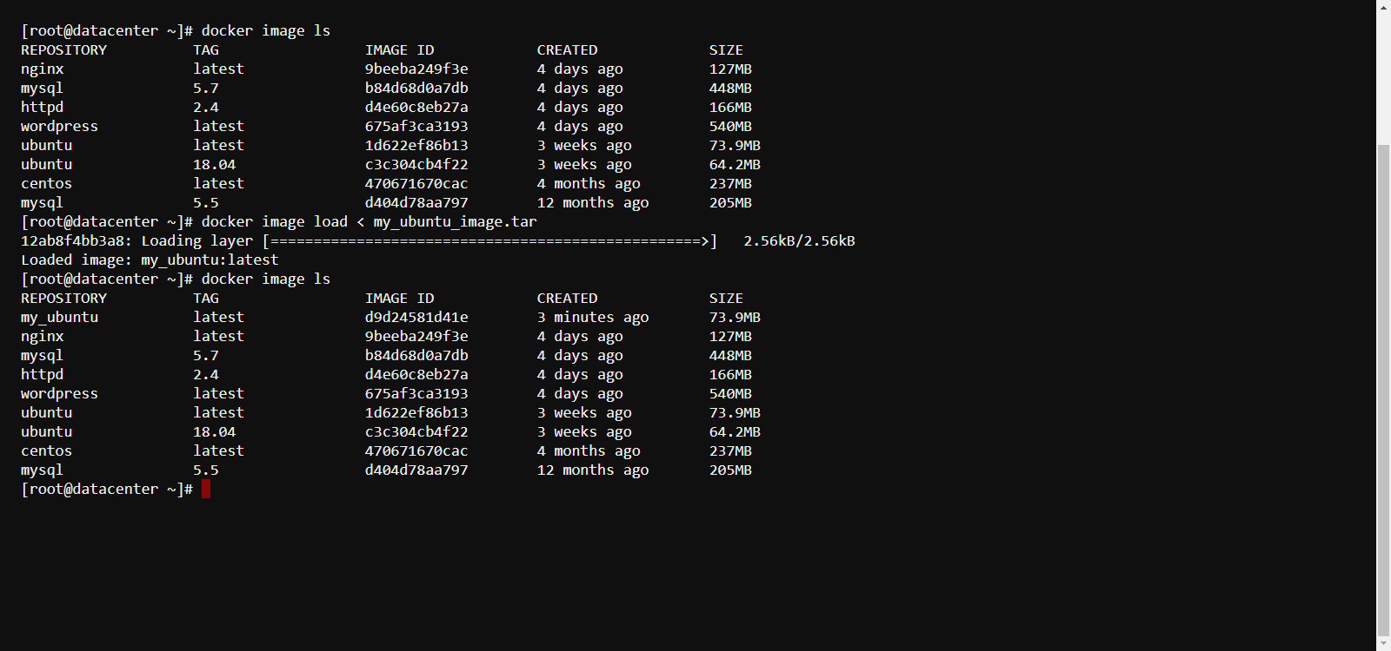

Step-5: Also, you can import the container image.

**Command: # docker container import my_ubuntu_image.tar my_ubuntu**

**Status:**

